

Head Teacher’s Update – Summer 2024

SCHOOL: | Nutfield Church | HEADTEACHER: | Imogen Woods | DEPUTY HEADTEACHER: | Anna Benjamin
TYPE: | Voluntary Aided | SCHOOL BUSINESS MANAGER: | Daniel Walker-Cheetham | SENCO: | Charlotte Cordey
LA: | Surrey | TERM: | Summer | FGB: | 4
Education Secretary: | Gillian Keegan | Diocesan Director: | Roz Cordner | Bishop of Southwark: | Christopher Chessun
Pupils on roll | 206 | Pupil Premium | 21 (10.2%) | SEN | 13 (6.3%)
Pupils by year group | YR 30, Y1 30, Y2 30, Y3 30,  Y4 27, Y5 28, Y6 31 | Free School Meals | 18 (8.7%) | EHCP | 1 (0.5%)
Attendance (01/09/23-25/06/24) | 95.79% | Looked After | 1 (0.5%) | English as an additional language | 7 (3.4%)
Authorised/Unauthorised | 3.03%/1.08% | Post Looked After | 2 (1.0%) | Young Carer | 3 (1.5%)

Teaching Staff For 2024-25

YEAR GROUP | TEACHER | TEACHING ASSISTANT(S)
R | Mrs Brooks | Mrs Kendall
1 | Miss Gibbins | Mrs O’Hanlon/Mrs Vaughey/Mrs Fowler
2 | Mrs Boyle/Mrs Blewitt | Miss Murray
3 | Mrs Cordey | Mrs Hargreaves-McCallum
4 | Mrs Rutter | Mrs Oastler/Miss Lindsey/Mrs Vaughey
5 | Miss Mitchell | Mrs Ross
6 | Mr Bowen | Miss Baber
Attendance
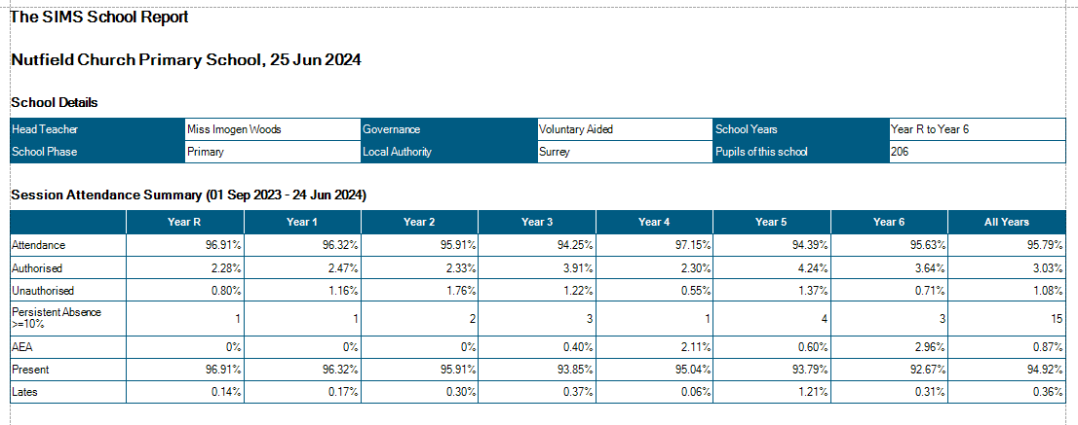

National absence data - academic year to date (to 14th June 2024) - source Gov.uk
5.4% in state-funded primary schools (3.9% authorised and 1.5% unauthorised)

DfE - further support to improve attendance
Looking ahead to the coming term, improving school attendance remains my number one priority and one which I know you share. Our recent reforms are designed to support the brilliant and innovative work you are already doing to address this issue. We are seeing the impact of this work – at the end of the spring term, new data showed that there are over 400,000 fewer children persistently absent or not attending school than last year. But there is still more to do.
- To help you embed the new regulations and statutory attendance guidance by September, we are running a series of training sessions and webinars over the coming months.
- We have also published guidance for schools, trusts and LAs to help you prepare for the mandatory collection of daily attendance data, which will begin in September.
The link between attendance and attainment, wider development and wellbeing is clear. Our analysis highlights that a 10 percentage point reduction in attendance is associated with a halving of the number of pupils who get a grade 4, 5 or above at GCSE English and Maths. That is why we will also be releasing more data tools and resources over the coming months designed to support you to make the strongest start possible come the new school year.

Data Headlines 2023-24
EYFS

 |  | Reception % EXS (achieved ELG)
2018 | 2019 |  | 2022 | 2023 | 2024 | National 2024 (2023)
90% | 90% |  | 90% | 90% | 93% | n/a (67%)

Key Stage 1

 |  | Year 1 Phonics % EXS
2018 |  | 2019 |  | 2022 |  | 2023 |  | 2024 | National 2024 (2023)
97% |  | 90% |  | 97% |  | 93% |  | 90% | n/a (61%)
 | Year 2 % EXS
 | 2018 |  | 2019 |  | 2022 |  | 2023 | 2024 | National 2024 (2023)
Reading | 93% |  | 90% |  | 91% |  | 87% | 87% | n/a (69%)
Writing | 90% |  | 87% |  | 83% |  | 80% | 80% | n/a (60%)
Maths | 97% |  | 90% |  | 88% |  | 93% | 87% | n/a (71%)

 | Year 2 % GDS
 | 2018 | 2019 | 2022 | 2023 | 2024 | National 2024 (2023)
Reading | 27% | 30% | 18% | 24% | 30% | n/a (19%)
Writing | 13% | 17% | 7% | 14% | 13% | n/a (8%)
Maths | 17% | 17% | 12% | 24% | 10% | n/a (16%)

Key Stage 2

 | Year 6 % EXS
 | 2018 | 2019 | 2022 | 2023 | 2024 | National 2024 (2023)
RWM | 79% | 91% | 75% | 74% | n/a | n/a (59%)
Reading | 79% | 91% | 84% | 74% | n/a | n/a (73%)
Writing* | 93% | 91% | 78% | 81% | 90% | n/a (71%)
Maths | 89% | 95% | 91% | 89% | n/a | n/a (73%)
GPS | 89% | 95% | 91% | 93% | n/a | n/a (72%)

 | Year 6 % GDS
 | 2018 | 2019 | 2022 | 2023 | 2024 | National 2024 (2023)
RWM | 10% | 18% | 6% | 22% | n/a | n/a (8%)
Reading | 24% | 36% | 34% | 37% | n/a | n/a (29%)
Writing | 24% | 32% | 15% | 30% | 16% | n/a (13%)
Maths | 24% | 32% | 32% | 56% | n/a | n/a (24%)
GPS | 45% | 73% | 47% | 63% | n/a | n/a (30%)

 | Year 6 Average Scale Score
 | 2018 | 2019 | 2022 | 2023 | 2024 | National 2024 (2023)
Reading | 105 | 107 | 105 | 107 | n/a | n/a (105)
Writing | n/a | n/a | n/a | n/a | n/a | n/a (n/a)
Maths | 106 | 107 | 106 | 110 | n/a | n/a (104)
GPS | 109 | 113 | 107 | 111 | n/a | n/a (105)

