HEADTEACHER’S REPORT

 |  |  | 
SCHOOL: | Nutfield Church | HEADTEACHER: | Imogen Woods | INTERIM DEPUTY HEADTEACHER: | Maryanne Boon
TYPE: | Voluntary Aided | SCHOOL BUSINESS MANAGER: | John Corlett | SENCO: | Charlotte Cordey
LA: | Surrey | TERM: | Spring | FGB: | 2
Education Secretary: | Gillian Keegan | Diocesan Director: | Roz Cordner | Bishop of Southwark: | Christopher Chessun
Pupils on roll | 205 | Pupil Premium | 21 (NCPS 10.2%) | SEN | 12 (NCPS 5.8%)  (National 17.1%)
Pupils by year group | YR 30, Y1 31, Y2 30, Y3 31,  Y4 27, Y5 27, Y6 29 | Free School Meals | 18 (NCPS 8.7%)  (National 24.6%) | EHCP | 4 (NCPS 1.9%)  (National 3.0%)
Attendance  01/09/23-23/07/24)  (02/09/24-18/11/24) | 95.72%  97.00% | Looked After | 1 (NCPS 0.5%) | English as an additional language | 7 (NCPS 3.4%)  (National 22.8%)
Authorised/Unauthorised  (01/09/23-25/06/24)  (02/09/24-18/11/24) | 3.23%/1.13%  1.87%/1.13% | Post Looked After | 2 (NCPS 1.0%) | Young Carer | 2  (NCPS 1.0%)  (National 0.5%)
AGENDA ITEM: HEADTEACHER’S SUMMARY REPORT
Please detail key events/actions since the last Academy Action Group meeting

Safeguarding
Single Central Record:
Single Central Record changes monitored:
Are there any changes to the SCR?
Are there any changes to the guidance?
Fire Drill
Alarm sounded at 08:38am prior to the school gate being opened. Teaching and support staff plus Ark children were on premise at the time of the alarm. All staff and children were immediately evacuated from the building. All at fire assembly point lined up, children quiet.FK carried out his usual checks of the area to ensure everyone had left the building. Ark staff had their emergency grab bags and took the register using the register from within their grab bag. SF completed a check of staff against the signing in book. All staff and children were present and correct. FK checked the fire alarm panel to seek the source of the fire/activation. The panel showed the Feed Room detector as the source. Upon arrival at the Tank Room there was no obvious reason for the alarm to have been activated and no smell of smoke. FK went out to the playground and informed IW of the reason for the alarm. FK silenced the alarm and reset the system. Staff, students and visitors returned to the building at 08:48am.FK Opened the school gates to allow children to enter the premises. This is the fire drill for one unplanned fire drill. We have had 5 more since (this section written on October 15th. All have been reported (SEE HTR1, HTR2, HTR3 and HTR4)
Attendance
Governors should be aware of the new guidance ‘Working together to improve attendance’ (SEE HTR5)
IW attended a SAfE webinar led by the Surrey attendance team. To hear this webinar please click on the link: This video is password protected. Please use password Attendance24 to access. https://vimeo.com/1015617528?share=copy. Notable comments are that ‘Case Work’ currently undertaken by the Inclusion Service will shift to schools. We have never authorised using the H code for authorised holidays due to the Governors policy not to grant leave however this coding has now been removed for all schools. There is a real sense that this new document further strengthens the view that no absence other than extreme cases (or genuine illness) should be permitted.
Governors who are new should be aware that the school currently does not use penalty notices. It may be useful for all Governors to review the national picture and learn more so that they can consider whether we should add fining in to our policies. An interesting aspect to note is the use in the guidance of educational neglect. This term has been used but has never been seen in guidance. This is indicative of the increased numbers of vulnerable pupils.

Place Planning
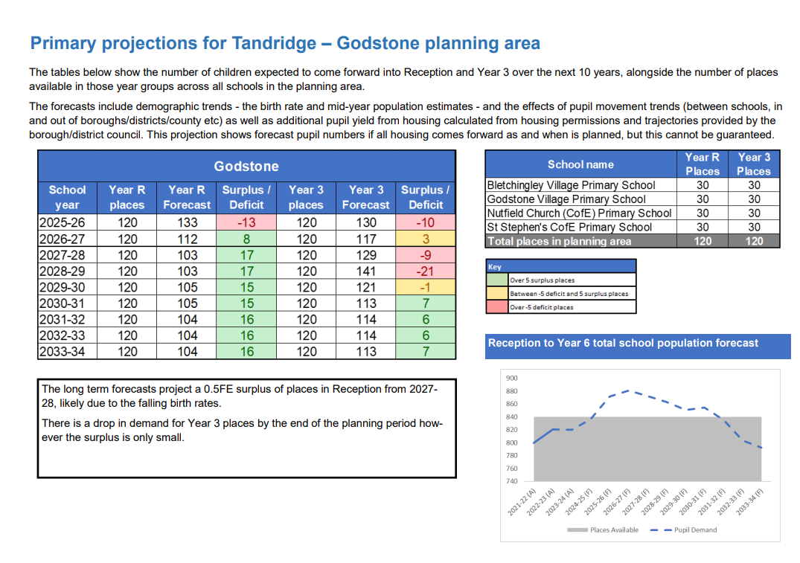
Place planning projections have been published. We are full in Years R and 3.
In 2023/24 8 children left the school
X1 sibling group moved due to relocation
X4 children moved due to relocation
X2 children moved to private education

In 2024/25 2 children left the school
X1 sibling group moved due to relocation

In 2023/24 4 children joined the school
X1 sibling joined
X2 children joined due to relocation (one with specific reference to quality of provision)
X1 child re-joined after returning from abroad

In 2024/25 7 children joined the school
X2 sibling groups joined due to relocation (one with specific reference to quality of SEND)
X2 children joined due to a relocation

There are currently 6 children on the waiting list for Year R

SDBE Ofsted Teams call notes 12/09/2024 (SEE HTR6)
NCPS Attendees: IW, JC, MB, CC, VC & SF
A Teams call was arranged by the SDBE Assistant Director for all schools who were ‘in the Ofsted Window’ in order to prepare us and inform us of current inspector training. Please see notes below taken by JC. There will be no lengthening of the notification time ahead of inspections. Graded Inspections will commence week of 23rd Sept and ungraded week of the 30th.
All calls will to inform of inspection will be on a Monday. If there has been no call before noon then there will be inspection in that week. Inspections will take place on Tuesday & Wednesday.
Day 1 typically 0800-1800. Day 2 0800 - 1700
“No-notice Inspections” will still be in place in the event of safeguarding concerns.
20% of all inspections will be graded. New inspection framework is in response to calls for more frequent inspections with lower stakes
More discussion will be had about local issues influencing education, local context which effects learning.
Single word judgements taken away to be replaced by an assessment against areas of school effectiveness.
Outcome will reference previous grade and call out trending standards either upwards or downwards. Focus will shift in the new
framework to look at:
Head’s ability to demonstrate focus on staff wellbeing. Governors focus on Head & SLT wellbeing. Bigger focus on SEND especially in KS1. The scope of what will be assessed remains unchanged but the focus will shift under the new framework.
Renewed focus on foundational knowledge. Primary focus on early English & maths. Expect there to be more dialogue with the school than pupils. Day 1 will focus on understanding leadership’s view of its educational context and environmental influence on learning.
Expect also that this will be done in a mobile setting, walking round the school rather than in an office.
Greater fluidity and flexibility for the inspector to react to discussion and move to areas within the school and inspect as they go.
Looking to ensure that inspections are less impactful to staff. They will be looking at how effectively children are learning and how well prepared they are for the next steps in their learning journey. Tailoring the pace of learning to a child’s readiness to move on.
Inspection in 3 or 4 focus areas:
2 will be in subject “streams” read, writing & maths knowledge will be one of them.
2 other broad areas will be assessed, could come from any areas of the school operation. Mobility, bullying, attendance, staff training & development.
All inspections will focus on securing foundational skills and knowledge before moving on.
Looking to develop communication & language. Looking to ensure that teachers do not over-support.
Vocab development will also need to be evidenced. Ensure staff use proper English in all communications.
Compliance will be a big focus. Ensuring that policies and websites are up to date. If there is a SEF (not compulsory) then it needs to be current, relevant and up to date. Important that Governors can evidence that they understand the school.
Curriculum needs to be well matched to the national curriculum with clear plans to implement and deploy. Staff training, CPD & subject knowledge.
Deep dive activities have not changed. There will be no meetings with teachers after lessons have been seen.
Safeguarding continues to be of paramount importance. Need to triple check the website, all links & policies.
Single central record is a big area of focus as before. Include only what is statutory. Prohibition check - need to do every TA to be sure.
Record keeping of safeguarding actions need to be evidenced. Follow ups are an area of weakness for many schools.
Inspectors will be looking for a strong culture of safeguarding. Evidence how Governing body knows that safeguarding is under control. (crib sheet is in the slides)

Ofsted Training Course 20/09/24 – (SEE HTR7 to be discussed in FGB)
Attendees: IW/CC

Artificial Intelligence
You may have read last year’s chrome AI call for evidence: https://www.gov.uk/government/calls-for-evidence/generative-artificial-intelligence-in-education-call-for-evidence.
From that there was an update published in April 2024: https://www.gov.uk/government/publications/ofsteds-approach-to-ai/ofsteds-approach-to-artificial-intelligence-ai. As we see more and more AI in schools and colleges, the school will be considering its use. Before using AI in classes we would like to gather views from other settings, our own team and of course from research which can highlight risks, safeguarding measures and impact.

Assessment
IDSR (SEE HTR8)
Redevelopments
Ethnicity data is now presented in a newly developed bar chart format, presenting all ethnic groups irrespective of what proportion of the school they represent. Where a school has a sixth form, an equivalent section will be displayed.
There is a new tabular presentation of suspensions and permanent exclusions. We have re-instated the year group information also in a tabular form.
There is a redeveloped section looking at pupils registered at other provision (including alternative provision) containing placements at unregistered provision and details of full/part time attendance, as well as whether placements are current or ended during the term. This year, the IDSR section on primary performance measures will not contain any key stage 1 attainment measures nor any key stage 2 progress measures. Introduction of EBacc attainment measures for English and Maths at grades 4 and 5. Improved group content that relates to potential complex pupil engagement with education. We have introduced destinations data for disadvantaged pupils at both key stage 4 and 16 to 18. https://idsr.ofsted.gov.uk/idsr/125193/#progress-attainment-ks1-ks2
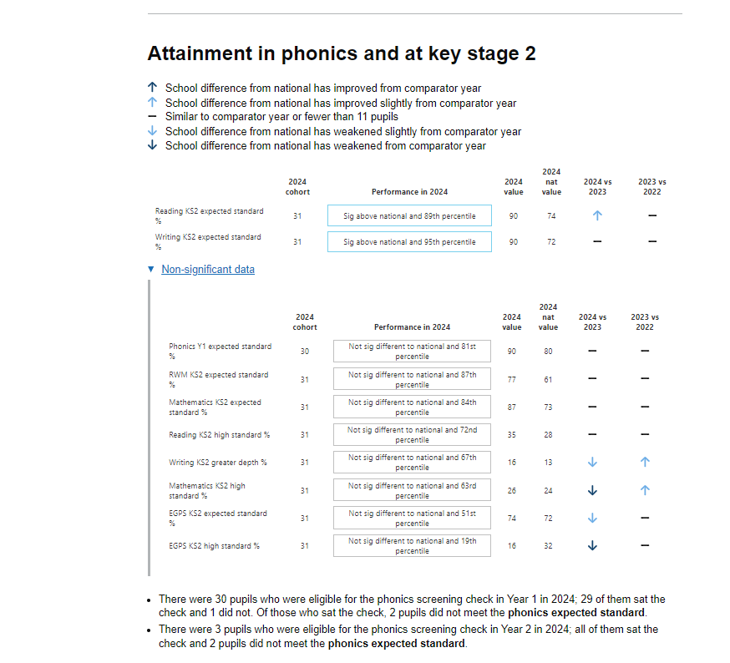

Statutory Data -Governors Webinar
This webinar was led by Maria Dawes (SAfE CEO) (SEE HTR9)

School Development Plan
Governors should read this document and be able to articulate our main areas of focus this year. Do remember to ensure you engage with the key documents
1 - Education Inspection Framework: https://www.gov.uk/government/collections/education-inspection-framework
2 - Keeping Children Safe in Education: https://www.gov.uk/government/publications/keeping-children-safe-in-education--2
3 - Working Together to Safeguard Children: https://www.gov.uk/government/publications/working-together-to-safeguard-children--2

Ark Update
At the last Environmental Health Inspection on 5th July 2024, Ark has achieved a Food Hygiene Rating of 5.
Head Teacher  The Ark Breakfast and Afterschool Club  Nutfield Church Primary School  Mid Street  South Nutfield  Redhill  RH1 4JJ | Our Ref:  If telephoning please ask for: Jackie Reid  Direct Line: 01883 732842  Email: Jreid1@tandridge.gov.uk  Date: 5 July 2024  Head Teacher  The Ark Breakfast and Afterschool Club  Nutfield Church Primary School  Mid Street  South Nutfield  Redhill  RH1 4JJ
Dear Food Business Operator,

Re: Food Safety Act 1990 (AS AMENDED)
The Food Safety and Hygiene (England) Regulations 2013
Assimilated Regulations 178/2002 and 852/2004
The Ark Breakfast and Afterschool Club, Nutfield Church Primary School, Mid Street, South Nutfield, Redhill, RH1 4JJ
I write further to a recent visit to your premises on 4th July 2024 the purpose of which was to check compliance with the requirements of food hygiene law, this visit was carried out with Ms Lynn Hargreaves-McCallum in attendance.
My visit involved an inspection of the premises, available documentation, procedures observed on that day and the food safety controls described or shown to me. No food or environmental samples were taken during my inspection.
The scoring of the inspection has been based on the low risk food preparation of sandwiches, fruit and cerals. There is no raw food poreparation or cooking involved in the food service.
Your premises were found to be operating at a good standard.
Your food hygiene rating
This authority operates the national Food Hygiene Rating Scheme. This is designed to help consumers choose where to eat out or shop for food by giving them information about the hygiene standards in food outlets at the time they are inspected to check compliance with legal requirements. Details of how ratings are calculated are enclosed, a sticker was left at the time of my visit.
Your score will be displayed on the Food Hygiene Rating Scheme website http://ratings.food.gov.uk after 21 days of this letter.
This report can be disclosed under the Freedom of Information Act 2000 upon request, unless any exceptions apply.
Please Note
If you are unclear about anything in the report, or require any advice or guidance please get in touch with me - my contact details are given at the top of this letter.

Yours sincerely
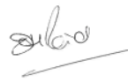

Jackie Reid
Senior Environmental Health Officer
Environmental Health & Licensing

The current Ark staffing rota will be reviewed at FWP 2 (SEE HTR10)

Reception baseline assessment
The school has completed the reception baseline assessment (RBA) for each child in our EYFS group. The RBA is held in the first 6 weeks after the children enter Reception.
Governors who are new and want to become familiar with the EYFS should read the EYFS policy, spend time reading the EYFS page on the school’s website and be aware of

Early Years foundation stage profile assessment
Schools must complete the early years foundation stage profile assessment between April and June of the academic year in which children turn 5, which is usually the reception year.

Optional key stage 1 tests
It is recommended that the optional key stage 1 tests are administered during May 2025.

Key stage 2 tests
The statutory key stage 2 tests are timetabled from Monday 12 May to Thursday 15 May 2025:
Date | Activity
Monday 12 May 2025 | English grammar, punctuation and spelling papers 1 and 2
Tuesday 13 May 2025 | English reading
Wednesday 14 May 2025 | Mathematics papers 1 and 2
Thursday 15 May 2025 | Mathematics paper 3

Multiplication tables check
Schools must administer the multiplication tables check within the 2-week period from Monday 2 June 2025.

Phonics screening check
Schools must administer the phonics screening check within the 1-week period from Monday 9 June 2025.

Academy Discussions – An Excerpt from the Director’s letter to Heads
New Trust Last year we informed you of the Board’s intention to create a second Multi Academy Trust for September 2025 to strengthen our offer for schools looking to become an academy in a Trust that meets their individual context and needs. Meetings took place over the spring and summer with secondary colleagues and the feedback has been helpful in developing a MAT that complements our current SDBE MAT as well as providing an alternative option for schools. We know that across the diocese we have a range of views regarding academisation, from those wanting to academise now to those with no plans to, and everything in between. We remain committed to allowing schools to make this decision if and when the time is right, if ever, but we are also committed to ensuring there is a strong offer that meets the needs of all our schools. During the Autumn term we will be hosting a serious of more focused events and meetings for headteachers and governing bodies to provide more detailed information. Corrina will send a separate poll for dates in November when we will have a clear idea on the direction of travel from the Secretary of state for Education.

Flourishing Together- A Collective Vision for the Education System
https://www.churchofengland.org/sites/default/files/2024-11/flourishing-together-a-collective-vision-for-the-education-system.pdf

SEND/Inclusion Update
SEND Report Autumn 2024
Mrs Cordey and Miss Woods have qualified as SENCO’s from the University of Roehampton. They will graduate on 23rd January 2025. Miss Woods continues to be the school’s Inclusion Lead, Mrs Cordey is now officially our SENCO.
It has been an exceptionally busy year so far in the world of SEN. We began the year by welcoming a new child in Year R who was about to be granted his EHCP for ASD. This has been a positive experience for parents and child and so far provision has been excellent with regular communication and I completed my first provision map. Well done to the Year R team for managing this without extra support. Later in the term, we welcomed a family of 3 children in Years 1, 4 and 6 and the younger one comes with an EHCP, again for ASD. This has meant that the Year 1 class is now 31, again well done to the Year 1 team for integrating him into a class where there is already undiagnosed SEN. Overall, for the SENCO, this term has been busy with a number of Parent and Carer meetings across the year groups as regular communication between SENCO, teachers and parents is key. In addition, I have been working with Surrey CC and Family Voice Surrey on the PINS project (Partnership for Neurodiversity in Schools). So far this has included a meeting with the representatives to give feedback on a parent questionnaire about our SEN provision, a parent meeting lead by Family Voice which was very positive in terms of support for parents and the opportunity to share their experiences with other parents, an OT champions meeting which involves looking at how we provide support and how we can further develop this in our school. There are two children who are receiving Speech and Language support and two other children who have come in to Year R with a plan and may need further support this academic year. This month we are due to start working on our Speech and Language project in which we will screen 20 children using a well-known assessment tool as part of a research project run by the University of Cambridge. We are now on the verge of confirming a fourth EHCP for a child in Year 4 which has been an ongoing process which has involved a tribunal involving parents and Surrey County Council. Since half term, I have met with the STIP team (Specialised Team for Inclusive Progress) for help in supporting 4 children in Year R, 2, 3 and 4 who are presenting behaviour which suggests a Special Educational Need. This term, parents who children are the SEN register or whose child has an SSA will be offered an extended Parent and Carer evening of 30 minutes.

